【 This is my face. 】
姓名：
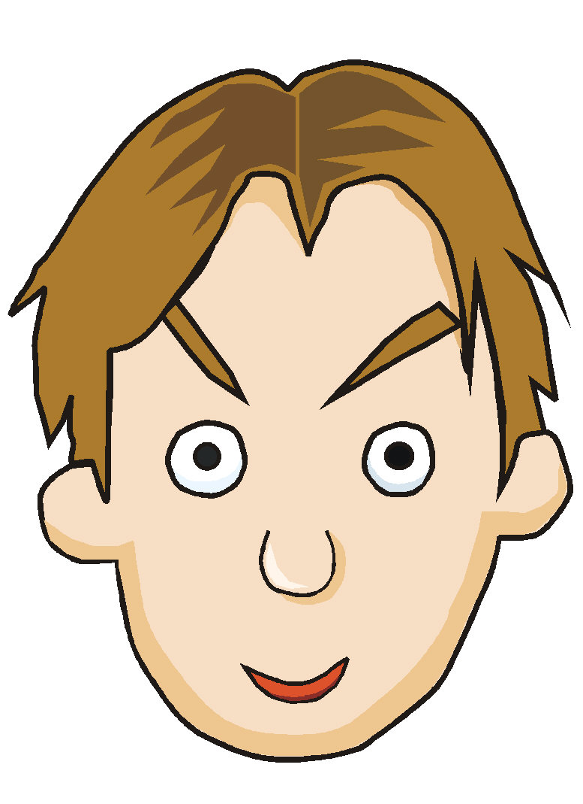

eye

ear

mouth

- Words＆Patterns：
eyes 眼睛 | nose 鼻子 | face 臉
ears 耳朵 | mouth 嘴巴 | head 頭
What is this? 這是什麼？
- Song：Head Shoulder Knees and Toes
Head shoulder knees and toes knees and toes

Head shoulder knees and toes knees and toes
And eyes and ears and mouth and nose
Oh head shoulder knees and toes knees and toes (Repeat Twice)

Head shoulder knees and toes knees and toes
shoulder 肩膀 | knees 膝蓋 | toes 腳趾

